Lecture 04 Homework

Implement the queries below using the db02 database

Work independently.

Put your queries into a submission file per earlier instructions. Name the file ‘04Homework’

Note problems 1 through 7 were part of the collaborative in class work.

Problems 1-7 5 points each

Problems 8-13 10 points each

1 - Find the number of meetings in each building – ordered by building ( A before B)

Column names: **building num_meetings**

2 - Show start time / end time for each meeting in building Order by starttime, roomNumber

Column names: **building roomNumber startTime endTime**

3 - Return the number of meetings in each room in each building order by building, roomNumber

Column names: **building roomNumber nummeetings**

**( Note – the query in the answer key was looking for meetings where the numMeetings was GT 4. I have put both in the answer key)**

4 - Find all meetings with no Moderator. Order by starttime

Column names: **purpose startime**

5 – Find the number of attendees in each meeting. Order by starttime, purpose

Column names **purpose, starttime, num_attendees**

6 – Find the number of available seats in each meeting. Order by available seats_available Ascending, starttime

Column names: **purpose starttime num_attendees, seats_available**

1. Find the moderator and type of meeting. List the combination of Moderator and Type only once. Order by name, purpose  
    Column names: **name purpose**
2. Find the number of meetings by moderator Order by Moderator

Column names: name, **moderator num_meetings**

1. Find the employee with the most meetings in the system.

Column names **name, num_meetings**

1. Find all attendees in any meeting going on at ‘2018-03-18 10:00’ Order by building, roomnumber

Column names: **name purpose starttime building roomnumber**

1. Create a list giving the count of phone numbers under each category ( Cell, Pager, etc) Order by category   
   Column names: **category, count**
2. The ‘Lunch’ meeting scheduled for 2018-03-28 has been canceled. Create a list of all attendees ( who have cell numbers) to the meeting and give the cell phone number for each. Order by name  
   Column name: **attendee cell_number**
3. Find all employes who are double booked. By double booked I mean employees who have two meetings they are attending that start at the same time. Order by name  
   Column Names: **name, nummeetings, starttime**

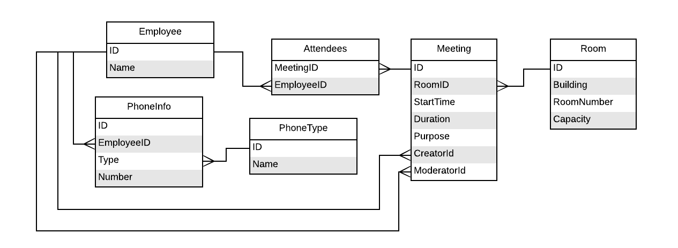

**Expected Output ( Note #6 wrapps the output line. Artifact of copying to word)**

Expected result of queries in homwork #4

CSS 475

Student Name

#1 - Number of meetings in each building order by building

building | num_meetings

----------+--------------

A | 9

B | 7

(2 rows)

#2 - Start time / End time for each meeting in building A

building | roomnumber | starttime | endtime

----------+------------+---------------------+---------------------

A | 101 | 2018-03-04 09:30:00 | 2018-03-04 10:30:00

A | 103 | 2018-03-04 09:30:00 | 2018-03-04 10:30:00

A | 102 | 2018-03-07 09:30:00 | 2018-03-07 10:30:00

A | 101 | 2018-03-11 09:30:00 | 2018-03-11 10:30:00

A | 104 | 2018-03-17 11:00:00 | 2018-03-17 12:30:00

A | 101 | 2018-03-18 09:30:00 | 2018-03-18 10:30:00

A | 103 | 2018-03-18 09:30:00 | 2018-03-18 10:30:00

A | 101 | 2018-03-25 09:30:00 | 2018-03-25 10:30:00

A | 104 | 2018-05-15 09:30:00 | 2018-05-15 10:30:00

(9 rows)

#3 - Num of meetings in each room in each building with Having

building | roomnumber | nummeetings

----------+------------+-------------

A | 102 | 1

A | 103 | 2

A | 104 | 2

B | 201 | 2

B | 202 | 1

(5 rows)

#3 alternate. With no having

building | roomnumber | nummeetings

----------+------------+-------------

A | 101 | 4

A | 102 | 1

A | 103 | 2

A | 104 | 2

B | 101 | 4

B | 201 | 2

B | 202 | 1

(7 rows)

#4 - Meetings with no moderator.

purpose | starttime

---------+---------------------

Lunch | 2018-03-21 12:00:00

Lunch | 2018-03-28 12:00:00

Lunch | 2018-04-05 12:00:00

(3 rows)

#5 - show number of attendees for each meeting

purpose | starttime | num_attendees

-----------------+---------------------+---------------

Staff | 2018-03-04 09:30:00 | 6

Staff | 2018-03-04 09:30:00 | 6

Team Build | 2018-03-07 09:30:00 | 6

HR Presentation | 2018-03-07 11:30:00 | 14

DB Issues | 2018-03-09 09:30:00 | 4

Staff | 2018-03-11 09:30:00 | 6

Post Mortem | 2018-03-15 09:30:00 | 6

Sales | 2018-03-17 11:00:00 | 3

Staff | 2018-03-18 09:30:00 | 8

Staff | 2018-03-18 09:30:00 | 7

Lunch | 2018-03-21 12:00:00 | 6

Staff | 2018-03-25 09:30:00 | 6

PlanningLunch | 2018-03-28 12:00:00 | 7

Lunch | 2018-03-28 12:00:00 | 7

Lunch | 2018-04-05 12:00:00 | 6

Post Mortem | 2018-05-15 09:30:00 | 6

(16 rows)

#6 - show number of available seats in use for each meeting

purpose | starttime | num_attendees | seats_available

-----------------+---------------------+---------------+-----------------

Post Mortem | 2018-05-15 09:30:00 | 6 | -1

Sales | 2018-03-17 11:00:00 | 3 | 2

Staff | 2018-03-18 09:30:00 | 8 | 2

Staff | 2018-03-04 09:30:00 | 6 | 4

Staff | 2018-03-11 09:30:00 | 6 | 4

Staff | 2018-03-25 09:30:00 | 6 | 4

Staff | 2018-03-18 09:30:00 | 7 | 13

Lunch | 2018-03-28 12:00:00 | 7 | 13

PlanningLunch | 2018-03-28 12:00:00 | 7 | 13

Staff | 2018-03-04 09:30:00 | 6 | 14

Post Mortem | 2018-03-15 09:30:00 | 6 | 14

Lunch | 2018-03-21 12:00:00 | 6 | 14

Lunch | 2018-04-05 12:00:00 | 6 | 14

HR Presentation | 2018-03-07 11:30:00 | 14 | 16

DB Issues | 2018-03-09 09:30:00 | 4 | 16

Team Build | 2018-03-07 09:30:00 | 6 | 24

(16 rows)

#7 - Moderator and type of meeting. Distinct

name | purpose

--------+-----------------

Albert | Post Mortem

Albert | Team Build

Alice | Staff

Dan | DB Issues

Jack | HR Presentation

Max | PlanningLunch

Max | Sales

Max | Staff

(8 rows)

#8 - Number of meetings by moderator

moderator | nummeetings

-----------+-------------

Albert | 3

Alice | 4

Dan | 1

Jack | 1

Max | 4

(5 rows)

#9 - Employee with most meetings in system

name | num_meetings

------+--------------

Dave | 11

(1 row)

#10 - All attendees in meetings going on at X ( 2018-03-18 at 10:00 )

name | purpose | starttime | building | roomnumber

---------+---------+---------------------+----------+------------

Dave | Staff | 2018-03-18 09:30:00 | A | 101

Jack | Staff | 2018-03-18 09:30:00 | A | 101

James | Staff | 2018-03-18 09:30:00 | A | 101

Martha | Staff | 2018-03-18 09:30:00 | A | 101

Alice | Staff | 2018-03-18 09:30:00 | A | 101

Albert | Staff | 2018-03-18 09:30:00 | A | 101

Sarah | Staff | 2018-03-18 09:30:00 | A | 101

Sarah | Staff | 2018-03-18 09:30:00 | A | 101

Sarah | Staff | 2018-03-18 09:30:00 | A | 103

John | Staff | 2018-03-18 09:30:00 | A | 103

Winston | Staff | 2018-03-18 09:30:00 | A | 103

Max | Staff | 2018-03-18 09:30:00 | A | 103

Dan | Staff | 2018-03-18 09:30:00 | A | 103

Ariel | Staff | 2018-03-18 09:30:00 | A | 103

Sarah | Staff | 2018-03-18 09:30:00 | A | 103

(15 rows)

#11 Count of phone numbers for each category

category | count

----------+-------

Cell | 10

Home | 8

Pager | 3

Work | 15

(4 rows)

#12 List of Work and Cell numbers for attendees.

attendee | cell_number

----------+-------------

Albert | 134-4567

Ariel | 126-5678

Dave | 127-7890

Jack | 128-6789

(4 rows)

#13 Show all double booked employees with the time they are double booked for

name | nummeetings | starttime

--------+-------------+---------------------

Albert | 2 | 2018-03-28 12:00:00

Sarah | 2 | 2018-03-18 09:30:00

Ariel | 2 | 2018-03-28 12:00:00

Sarah | 2 | 2018-03-18 09:30:00

(4 rows)